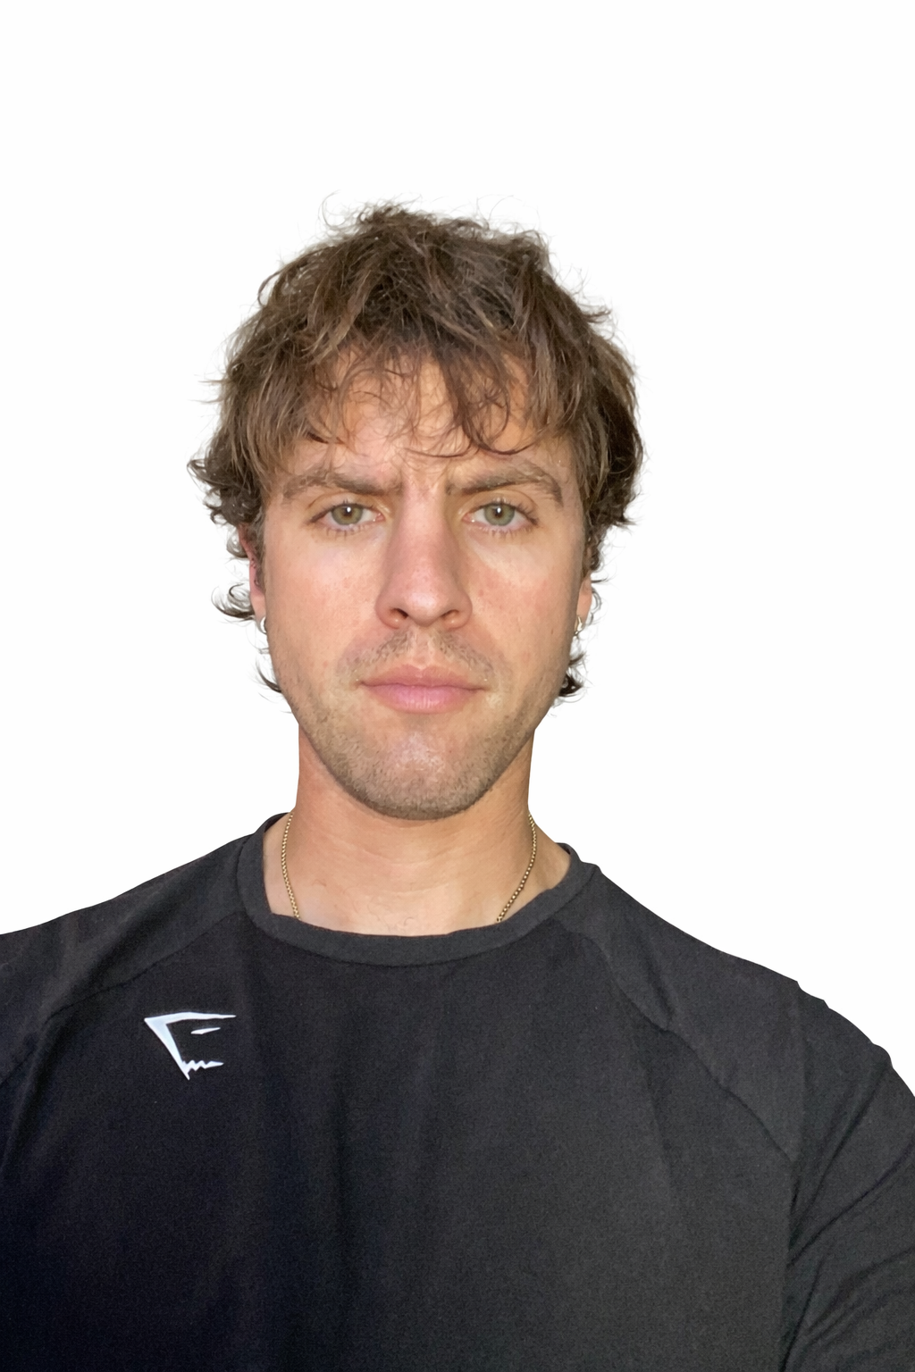

Camerin Pickering– Archery
4 Year Plan 2026 – 2029
Age: 26 years

Date of Birth: 28 May 1999
Nationality: Bermudian (birth)

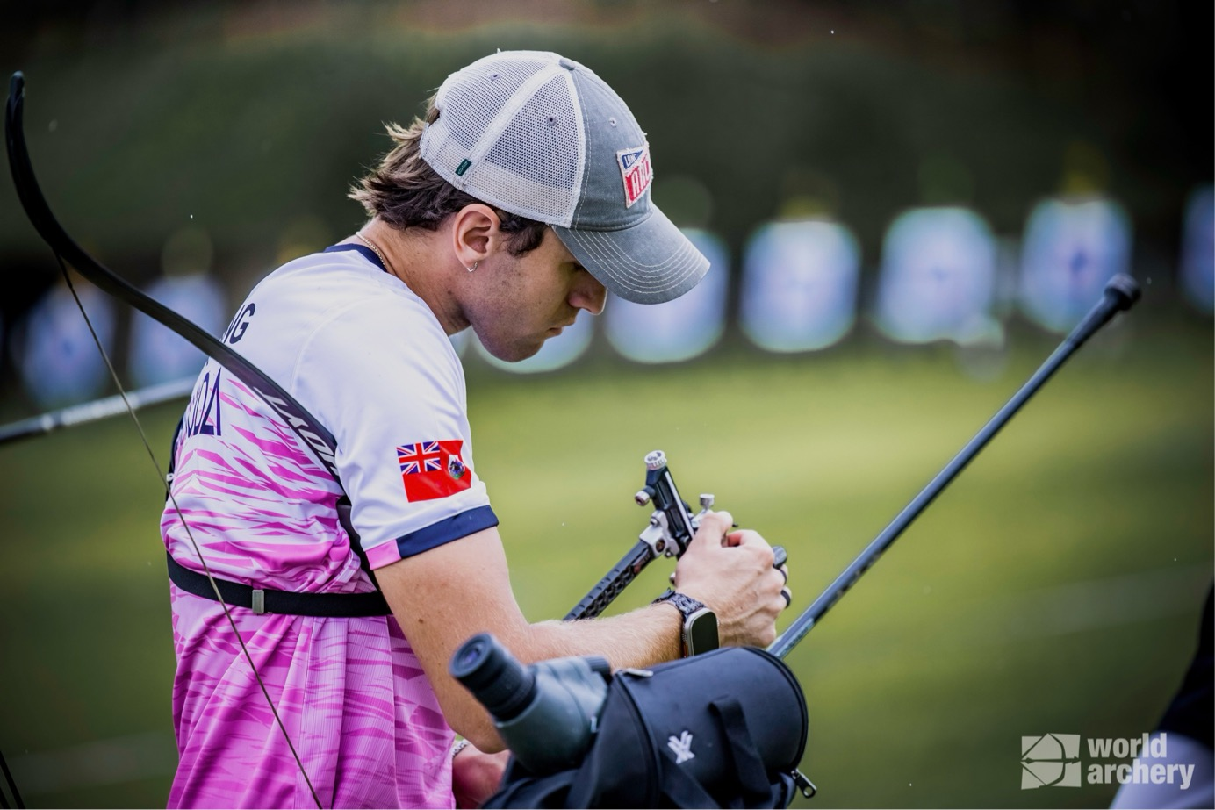
Photo supplied by World Archery: World Archery Championships Gwangju Korea 2025

Goal:
To represent Bermuda at the highest level of international archery, with the long-term objective of qualifying for and competing in major multi-sport events including the Central American & Caribbean Games, Pan American Games, and ultimately the Olympic Games. My focus from 2021–2025 was to build international experience and reach consistent Olympic-level scoring (640+ at 70m). I achieved this milestone in 2023 and recorded a national record in 2024.
From 2026–2028, my goal is to:
- Consistently perform above Olympic qualifying standards
- Advance deeper into elimination rounds at World Cups and Championships
- Secure qualification and strong performances at major games
- Peak for Olympic qualification events

Events from 2021 – 2025

2021

The Vegas Shoot – Virtual Online
- Finish: 14th/141 (Recurve Flights)
- Score: 827/900

2022
Puerto Rico Cup (Men’s Recurve)
- Finish: 10th/28
- Score PB: 617/720
Copa Merengue – CAC Qualifier (Men’s Recurve, WRE)
- Finish: 10th/38
- Score PB: 629/720
Hyundai World Cup Stage 4 – Colombia (Men’s Recurve, WRE)
- Finish: 80th/91
- Score: 610/720
Pan American Championship – PanAm Qualifier (Recurve Men)
- Finish: 29th/66
- Score PB: 634/720 (WRE)

2023
The Vegas Shoot
- Finish: 14th/384
- Score PB: 851/900
Hyundai World Cup Stage 4 – Paris (Men’s Recurve, WRE)
- Finish: 89th/128
- Score PB: 644/720 (Achieved minimum Olympic qualifying score)
Lancaster Archery Fall Harvest Shoot
- Finish: 1st/4
- Score: 550/600

2024
The Vegas Shoot
- Finish: 30th/450
- Score PB: 837/900
Pan American Championships – Medellín, Colombia
- Score: 646/720 (National Record)
- Ranking: 28/58
- Advanced through elimination rounds (won 1/24 match 6–2)
Continental Olympic Qualifier (Americas) – Medellín, Colombia
- Quarter-finals: eliminated 6–4
- Final placement: 5th overall
Indoor Archery World Series – Switzerland
- Qualification Score: 562/600 (18 m)
- Finish: 19th place, men’s recurve
Bermuda Indoor Nationals
- Score: 564/600
- Finish: 1st place (Senior Men’s Recurve)

2025
Bermuda Outdoor Nationals
- Qualification: 588/720
- Result: Gold Medal – Matchplay Champion (Senior Men’s Recurve)
World Archery Championships – Gwangju
- Score: 608/720
- Rank: 139/153 archers
- Field: 75 countries
Hyundai Archery World Cup – Stage 4, Madrid
- Qualification Score: 623/720
Hyundai Archery World Cup – Stage 1, Florida
- Qualification Score: 608/720
- Eliminated 0–6 in first elimination match
Copa Merengue – Dominican Republic
- Result: Bronze Medal, Men’s Recurve
- Key Match: defeated Daniel Ragbir (Trinidad and Tobago) 6–4
- Secured individual qualifying spot for 2026 CAC Games

Development Plan (2026 – 2029)
My training and competition plan over the next four years includes:
- Competing in World Archery World Cups and Championships annually
- Participation in international training camps and high-performance environments
- Continued development with local and international coaching support
- Focus on both qualification scoring and matchplay performance

Major Target Events:
- 2026: Central American & Caribbean Games
- 2027: Pan American Games
- 2027–2028: Olympic Qualification Events
- 2028: Olympic Games
I will continue to refine technical consistency, mental performance, and match strategy to ensure peak performance at major qualification events.

